**PROJECT 5**

**Report:**

* This project is about a portfolio website. In this, a user can document all their achievement, skills, abilities, and potential and till date work and education history.
* Not like a resume where a person has to sum up their capabilities in one to two pages. This platform provides the user to elaborate and project each and every detail what they regret, not be able to show on the resume.
* This website helps individuals to apply for jobs, apply to colleges, or any training programs.
* In this project, we have user who sign up and create their portfolio which contains all their personal and critical information. He is the owner or admin of his/her portfolio.
* Then there is a viewer who can go to the users or admins website and view all the information he/she has given there.
* The viewer of the website can only read the information and not make any changes to it. Only admin can edit and change his/her website.
* In this project, various frames are depicting a different aspect of the person to make their career path more accessible.

**Admin:**

Id: Akshaya

Password: aaaaa@1A

Admin landing page after login: <http://localhost:8000/entry>

**Guest**:

The gust landing page is: <http://localhost:8000/entry>

Guest needs to login. Guest can view Portfolio.

**Visitor:** Visitor can only download resume.

**The frames are:**

1. Home Page: Where you have to sign up and log in.
2. About Me: All the personal details about the user is stored here like name, phone number, address, email, social profiles, nationality, and so on.
3. Skills: Where all the expertise of the person is present like technical skills, transferable skills and languages are known, etc.
4. Resume: This page reflects the highlights of the person like work experience, company name, position, and working span in that company.
5. Blog: This is the blog page where he/she can write to share their views on an individual subject.
6. Hire Me: This page a person can get hired for tasks specified in it.
7. References: On this page recommendation of various people is done for the user who is admin or owner of that page. Moreover, the viewer can see all the recommendation given to the user and get an impression.
8. Contact Me: The viewers of the page can contact the user(who is admin and page owner) and send message(an email is directly sent to admin) to the user if they want.
9. Portfolio: On this page, all the professional history is present of the user like all the project done, all the paper published, patents, researches were done, and any achievements, etc.
10. Education: All the education history is placed on this page like degree, University, etc.
11. Experience: The work experience is present here.
12. Entry: Where use can registers and log in. And even visitors view if the use don’t want to register, here they can simply download the resume.
13. Admin Panel: Here the only admin can enter and make changes to the database.
    1. About Me: Change data for about table.
    2. Login Details: Can change user name and password.
    3. Resumes: Add or delete resume details.
    4. Hireme: Add or delete hireme page details.
    5. References: Add or delete references page details.
    6. Skills: Add or delete skills page data.
    7. Portfolio: Add images for portfolio page. And add new resume to be downloaded on entry and home pages.

**Laravel Steps:**

* I continued working in the Coins folder, which was installed in class following the nine steps present in the laravel document. Downloaded composer. Installed Laravel .Then created laravel database. Then changed the database name as laravel in .env file. Then performed "php artisan migrate".
* Then I imported my all database tables in the same database "laravel."
* Wrote Models for all the tables in the app folder. And use it in the FormController.
* Created all the pages in the views/forms folder according to the laravel format and used all my tables inside it to load data in HTML frames. In the same file wrote JavaScript, Php code, and its validation. I have done this for all the frames I mentioned above. I have made these files as .blade.php extension.
* Placed css in public folders. So inside a public folder, I have created a folder named CSS, which has the CSS file in it.
* Wrote appropriate code in the routes/web.php to display pages and establish connections with the database.
* Wrote necessary code in Controllers/FormController.php to establish a proper connection to the database and use it to access to it.
* For all php function used in the .blade.php(HTML) write it in side the Controller. And wrote the connection code inside route for every functions to connect with the functions and blade files.

**Screen Shot of Tables with data in it(testing of Database): -**

1. About

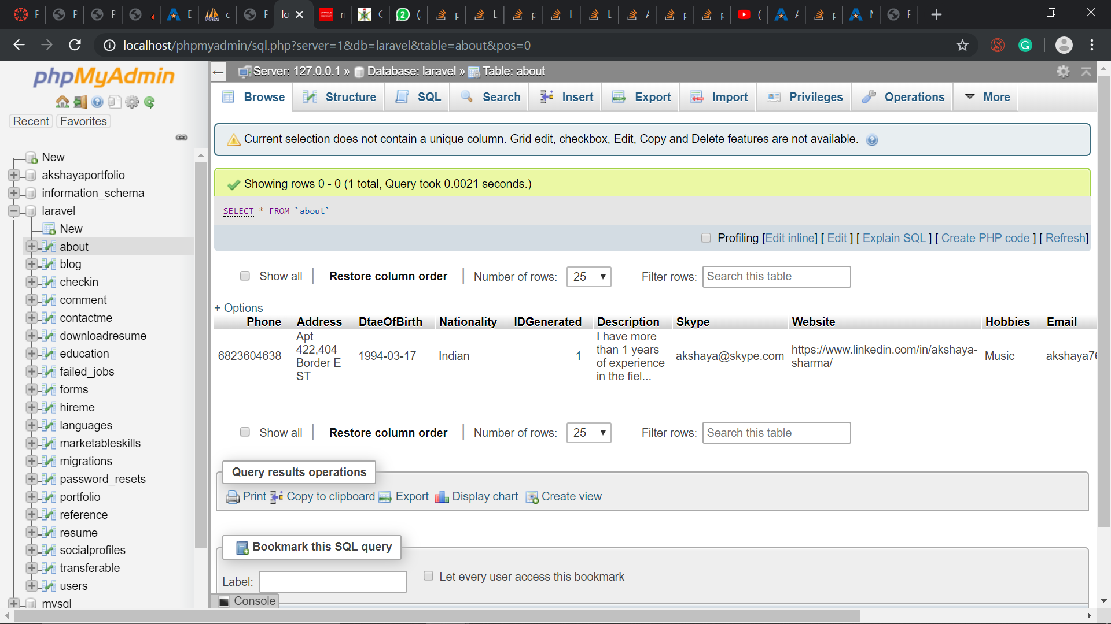

1. Blog 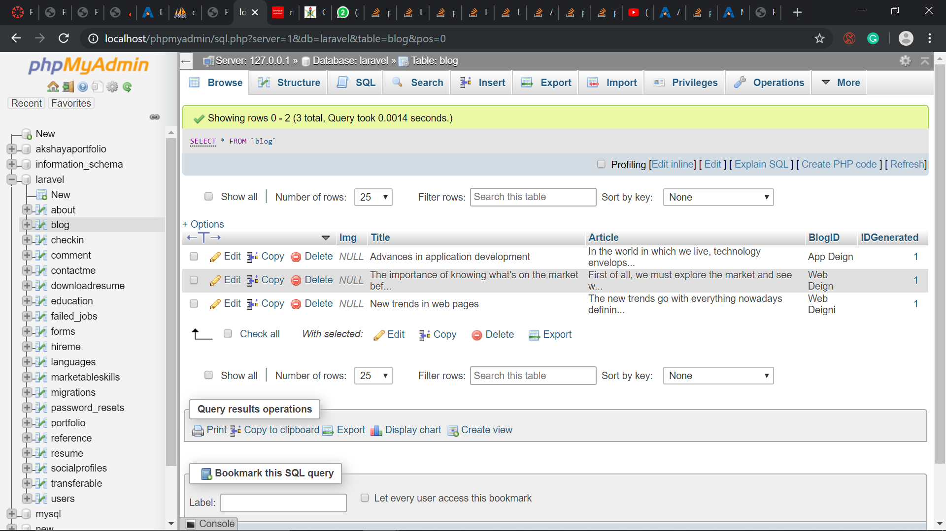
2. CheckIn 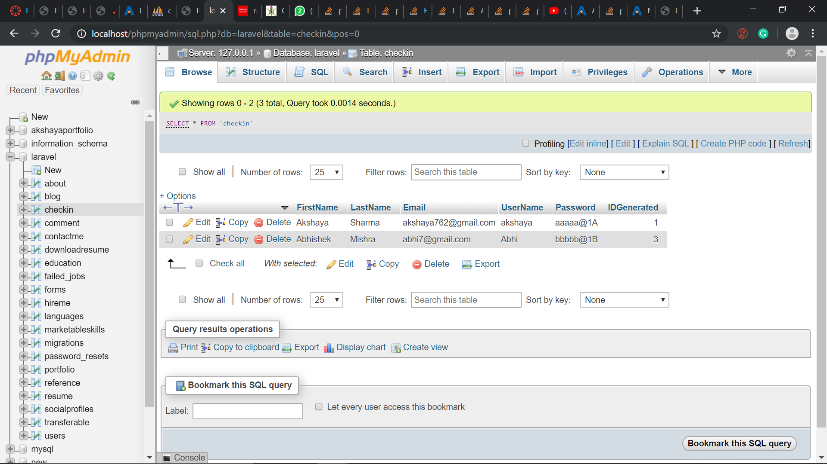
3. HireMe

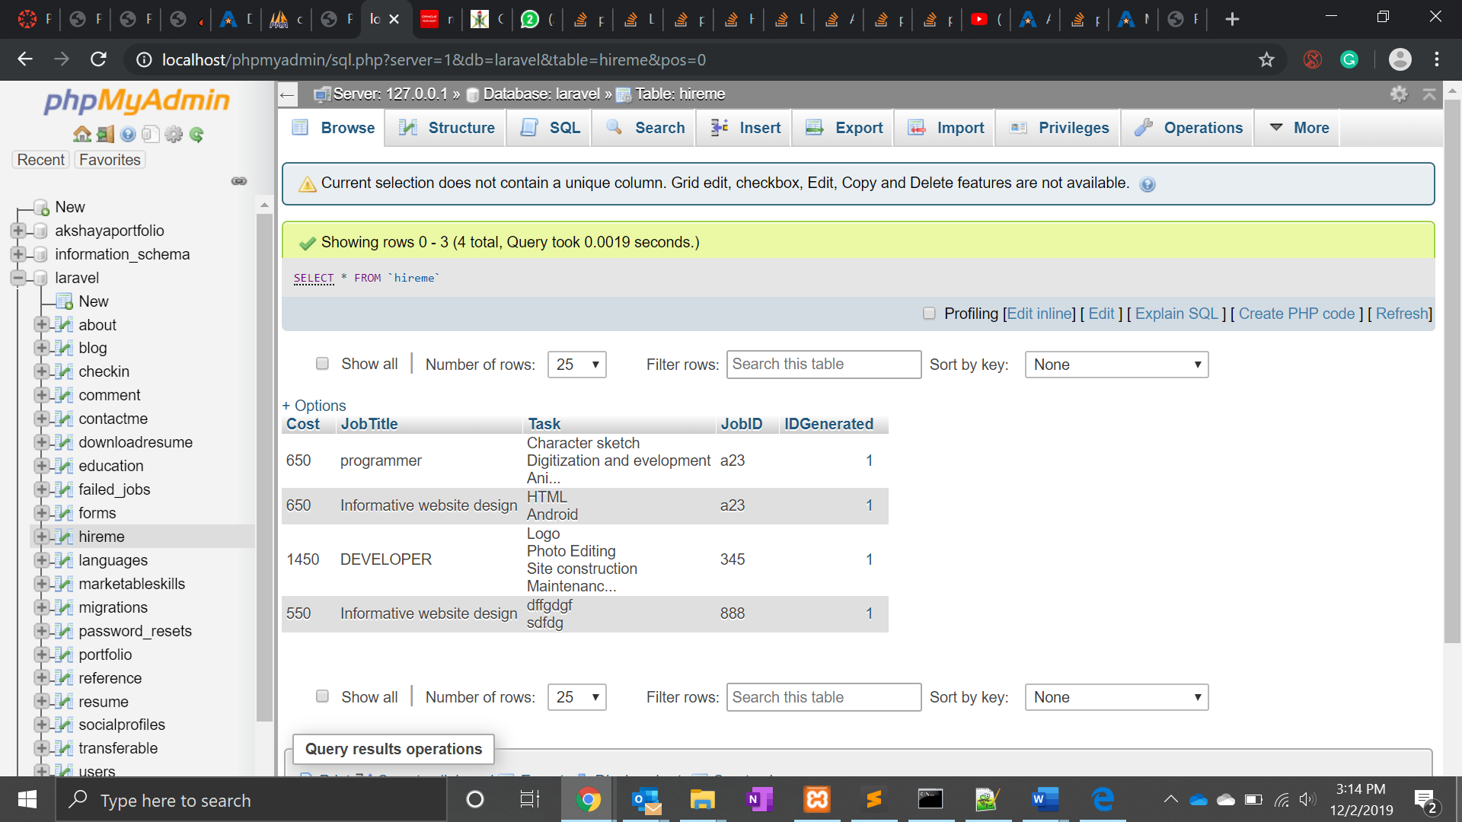

1. Languages

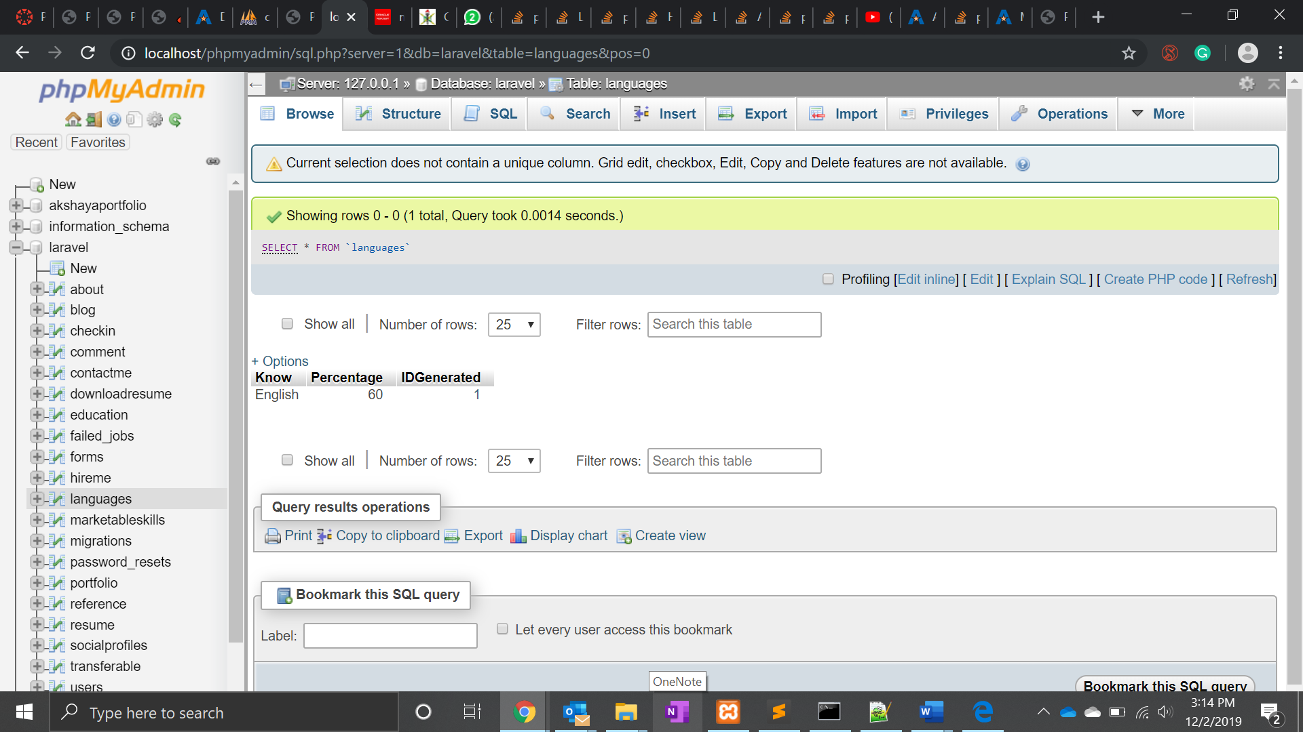

1. MarketableSkills

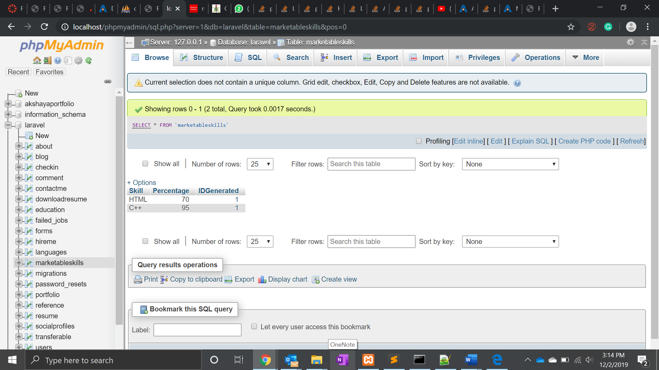

1. References 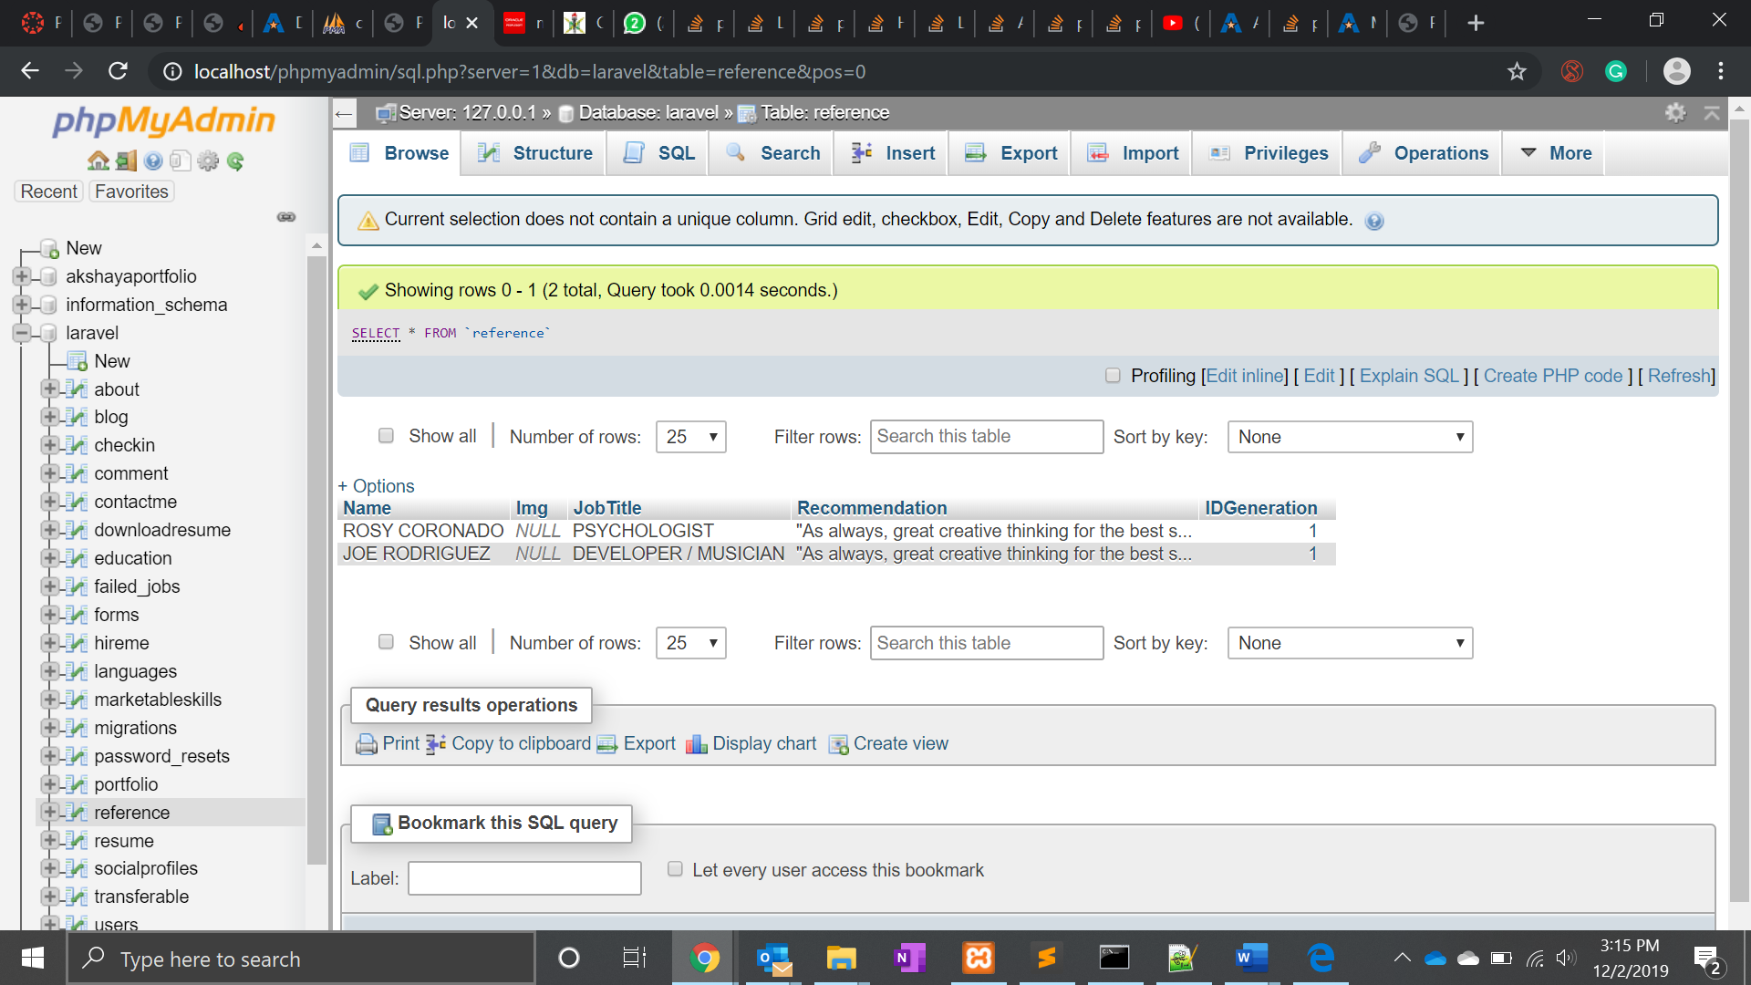
2. Resume

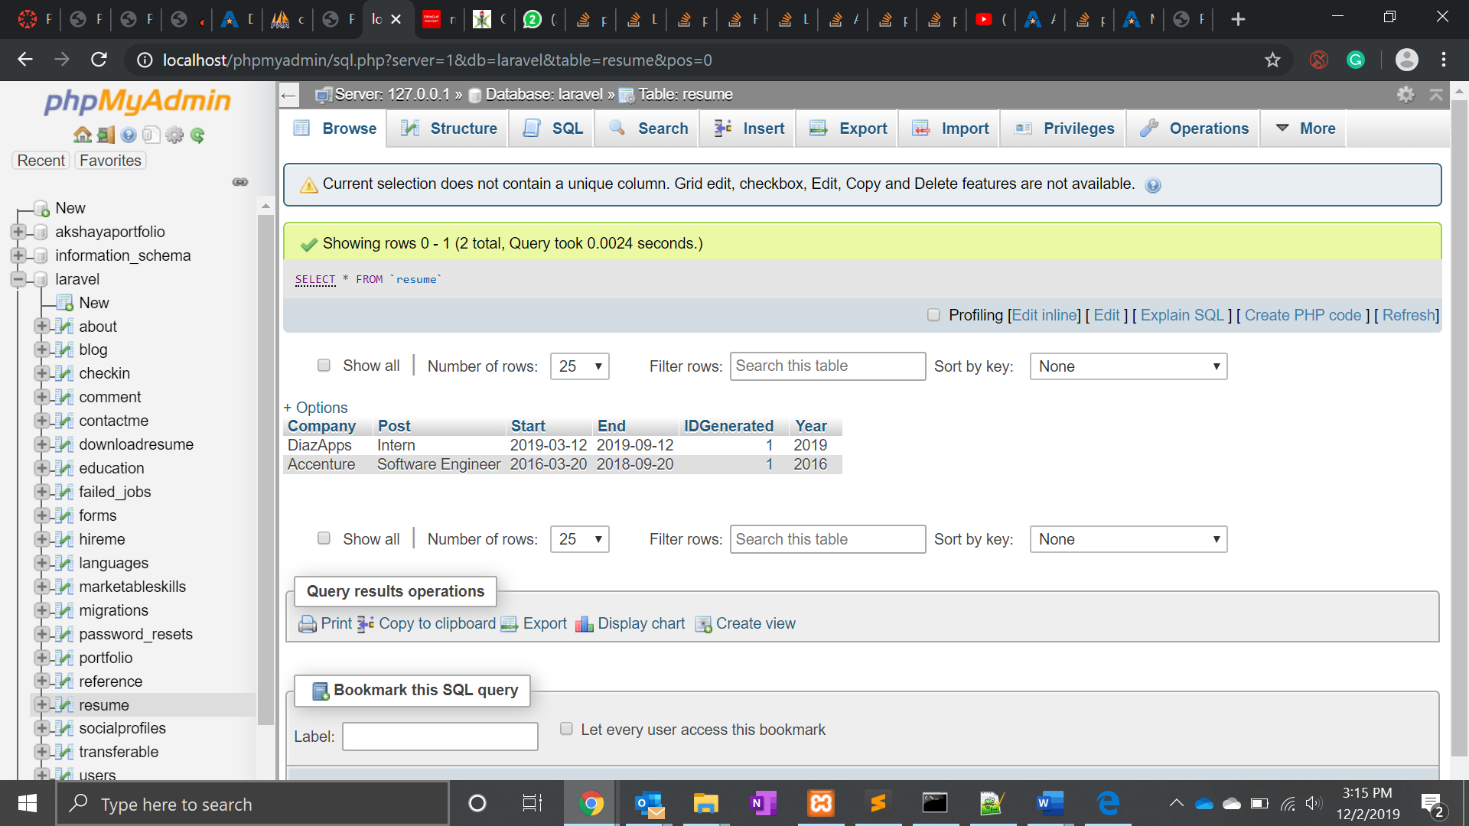

1. Transferable

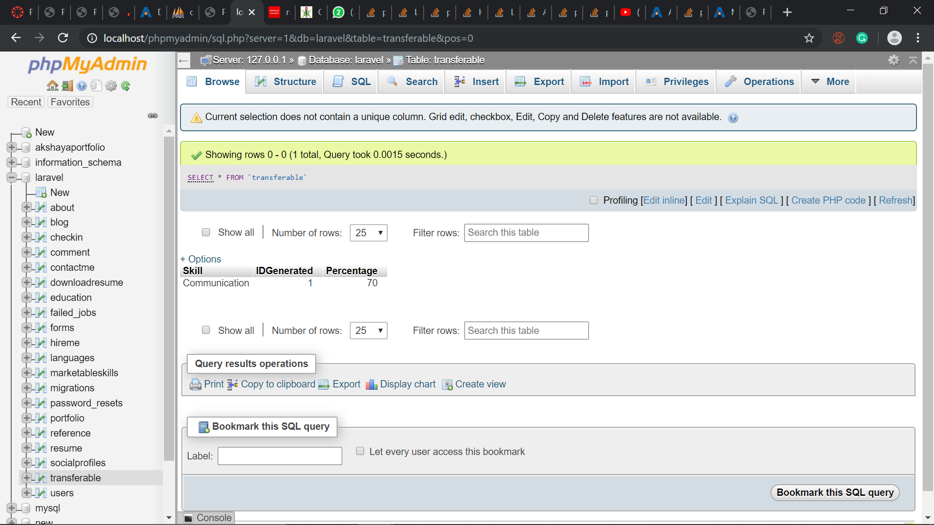

Few screenshots of implementation(My implementation code is very huge and consists of many files. Because of that I am unable to attach every thing.Only patches of my code I am able to attach):-

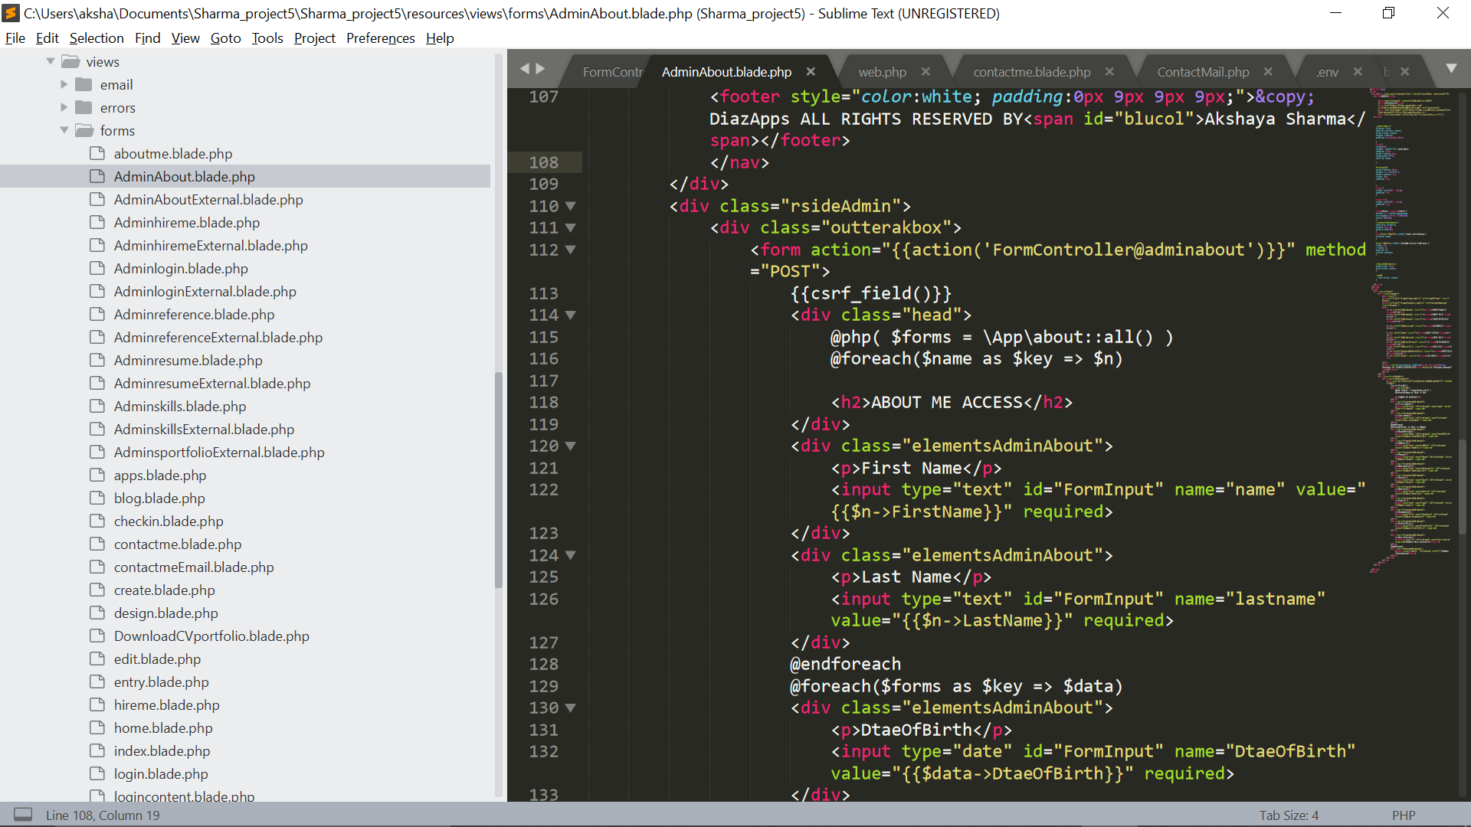

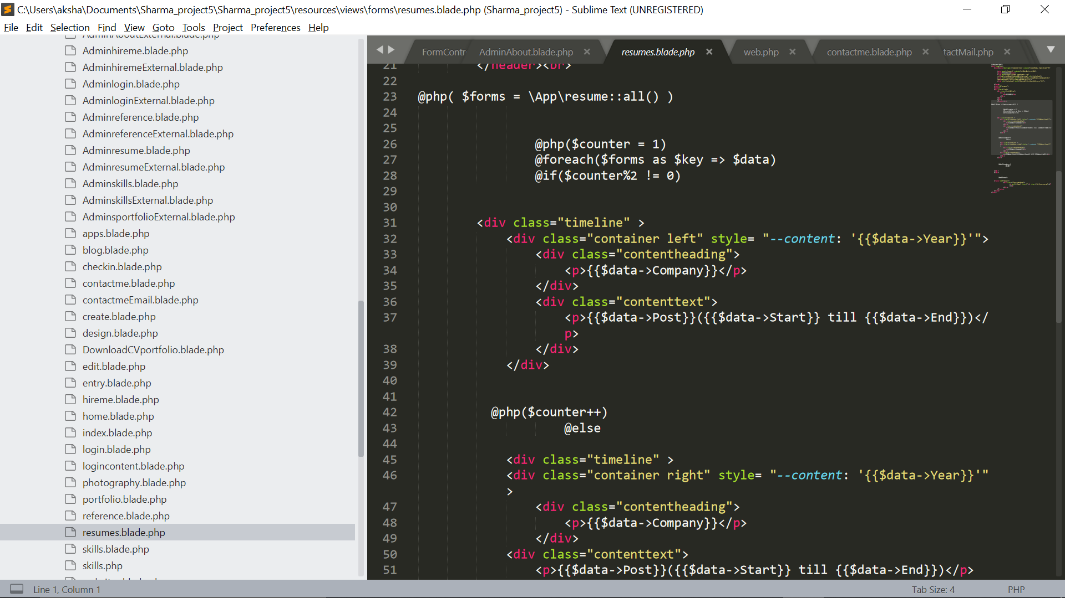

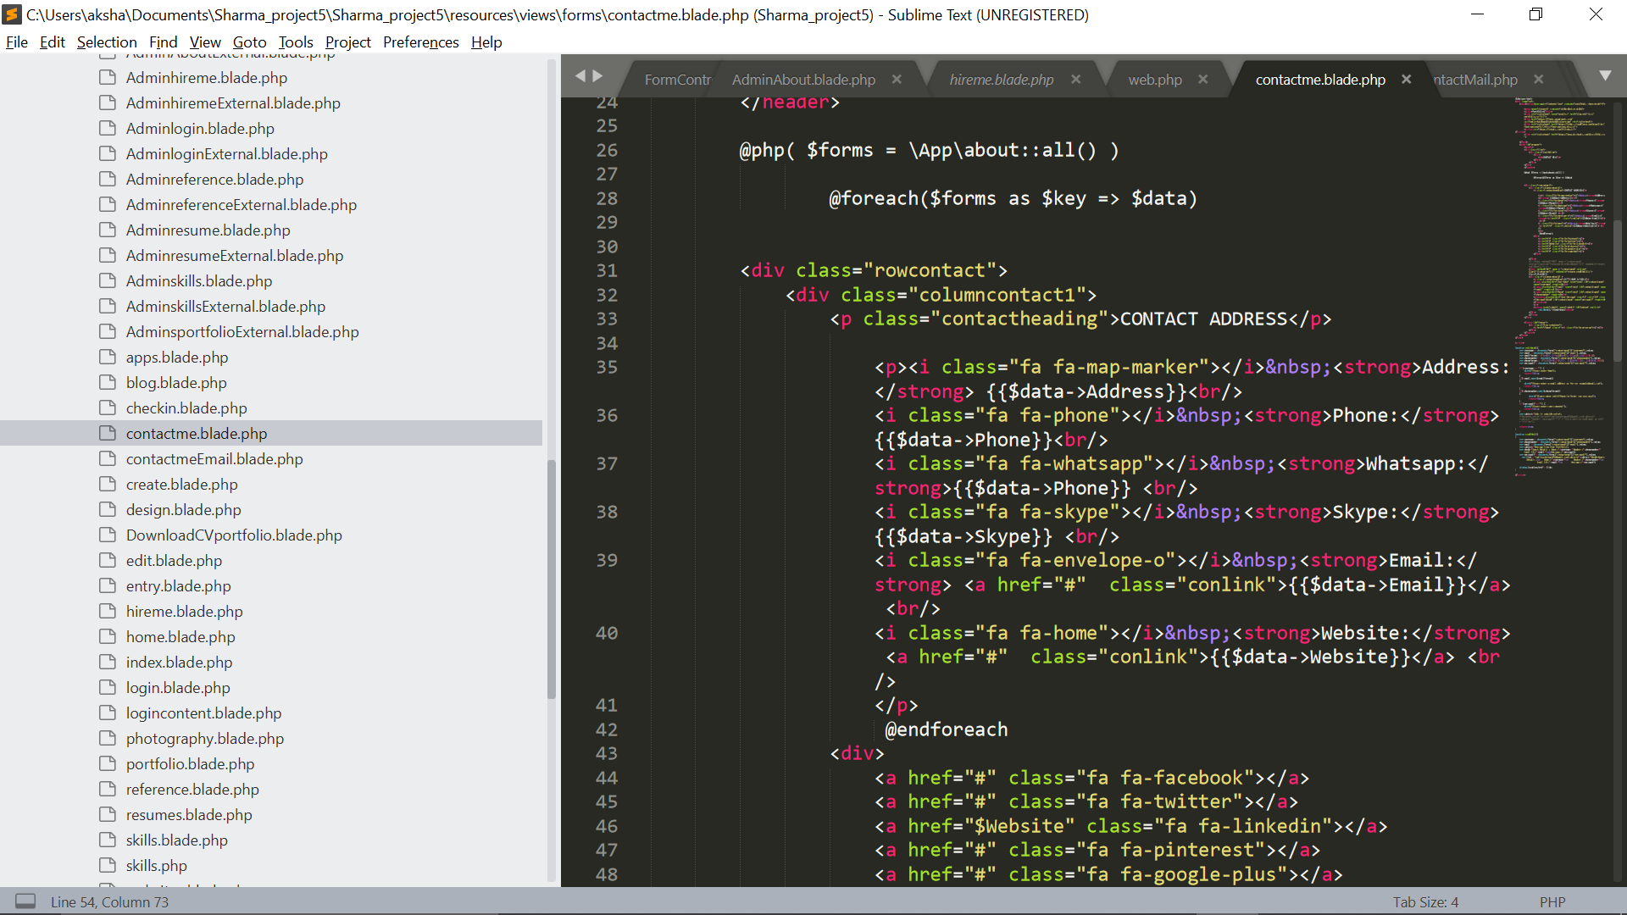

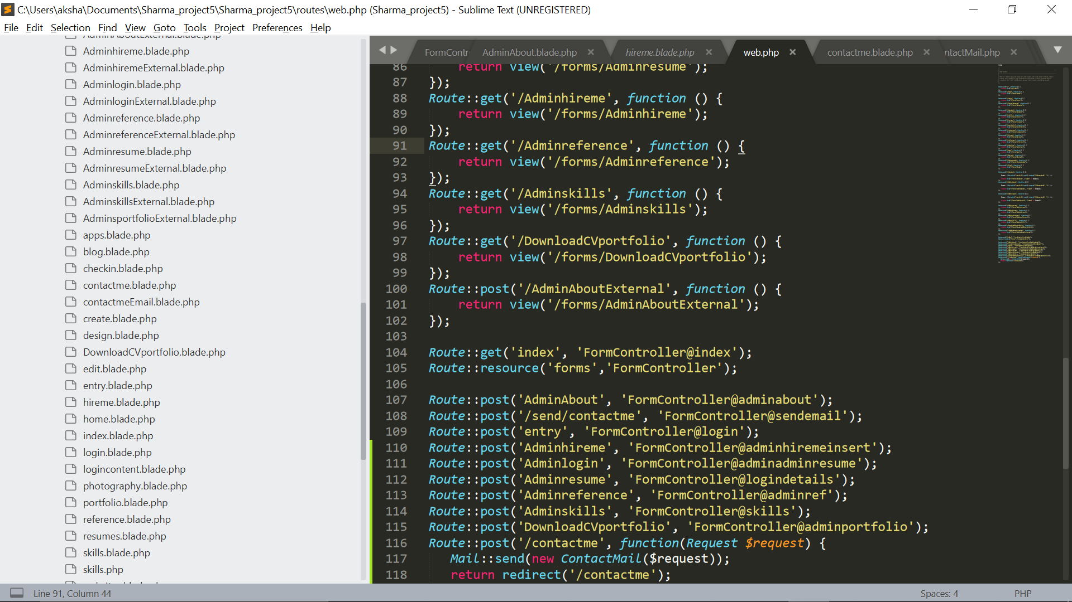

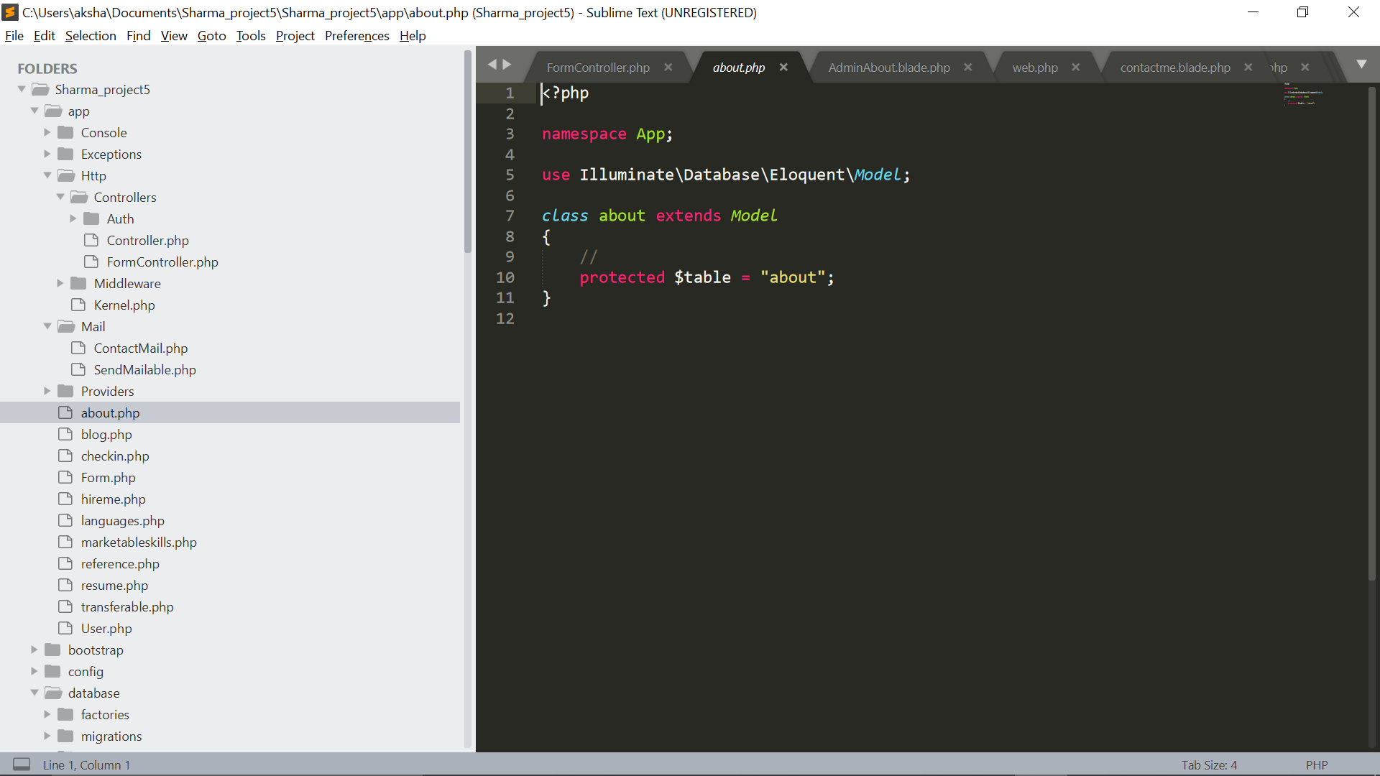

**Screenshot of Project: -**

**Landing link:** <http://localhost:8000/entry> 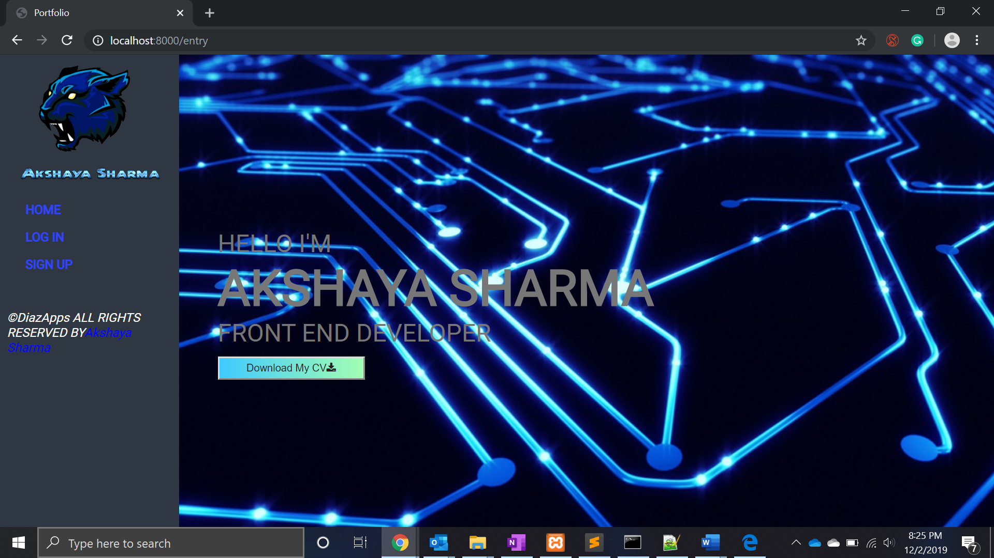

Email:

